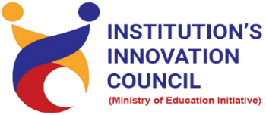
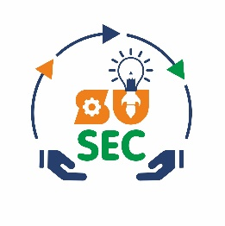
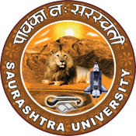
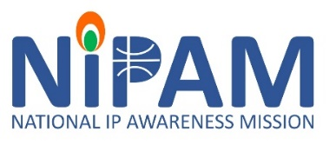
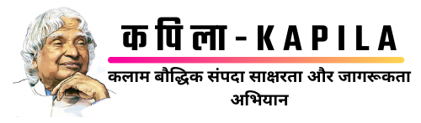

Institution's Innovation Council
Saurashtra University

Patent Prosecution in India
06 January 2023
At
NFDD building
Saurashtra University, Campus, Rajkot
Contents
Saurashtra University – IIC 2
NIPAM (National Intellectual Property Awareness Mission) 2
Event Schedule 3
Event Registration Link 3
Brief about Event 4
Key Points 5
Outcome 5
About the Speaker/Chief Guest 6
Connect Us: 8

Saurashtra University – IIC

The university is dedicated to instruction, research, and extending knowledge to the public (public service). Ministry of Education (MoE), Govt. of India has established ‘MoE’s Innovation Cell (MIC)’ to systematically foster the culture of Innovation among all Higher Education Institutions (HEIs). The primary mandate of MIC is to encourage, inspire and nurture young students by supporting them to work with new ideas and transform them into prototypes while they are informative years. Saurashtra University is one the Organization that have constituted the IIC to foster the vision of MoE and be a part for the promotion and development of innovation ecosystem.

NIPAM (National Intellectual Property Awareness Mission)

National Intellectual Property Awareness Mission (NIPAM), launched in 2021, has achieved the target of imparting Intellectual Property (IP) awareness and basic training to 1 million students. The program is being implemented by the Intellectual Property Office, the Office of Controller General of Patents, Designs and Trade Marks (CGPDTM), Ministry of Commerce and Industry.
National Intellectual Property Awareness Mission (NIPAM) under the initiative of the Government's "Azadi ka Amrit Mahotsav". The pan-India ambitious mission aims to provide awareness on Intellectual Property and its rights to 1 million students. It aims to inculcate the spirit of creativity and innovation to students of higher education and ignite and inspire the students of college/Universities to innovate and protect their creations.

Event Schedule

Time | Program
10:30 am | Registration & High Tea
11:00 am – 11:15 am Inauguration & Welcome
11: 00 | Inaugural Session of Patent Prosecution in India
11:02 | Welcome
11:03 | Brief about IIC & Incubation Centre by Dr. Ranjan Khunt, President - IIC
11:06 | Speech by Respected Mr. Amit Parekh, Registrar, Saurashtra University
11:08 | Speech by Eminent Speaker Mr. Sagar Baburao Pol, Assistant Controller of Patents & Designs.
11:10 | Speech by Hon. Vice Chancellor. - Prof. Girish Bhimani, Saurashtra University on importance  of Patent for Start-ups
11:13 | Vote of Thanks by Dr. Harikrishna Parikh, Vice President – IIC
11:15 | National Anthem
11:16 | Expert Session by Eminent Speaker Mr. Sagar Baburao Pol, Assistant Controller of Patents & Designs.
01:30 | Question Answer Session
02:00 | Concluding and Thanks - Mr. Parth Sejpal, CEO, SU Startup And Entrepreneurship Council

Event Registration Link

bit.ly/SU-PPI-NIPAM

Brief about Event
This Seminar organized by Saurashtra University Start-up & Entrepreneurship Council (SUSEC) with support of National Intellectual Property Awareness Mission (NIPAM) and office of the controller general of Patents, Design and Trademarks. To foster the culture of Patent and Start-up in Saurashtra region and inspire young entrepreneurs. That was an exclusive event for start-ups, students and new age entrepreneurs from the Gujarat start-up ecosystem.
Patent Prosecution in India is not merely the interaction between an applicant and the Indian Patent Office (IPO), but it is a test of the legal and technical competencies of an invention. The first stage involves filing an application, which is followed by its publication by the Patent Office was made understood by the speaker. Also, many examples of patents, Trademarks, Designs and copyrights were given by Speaker.
Awareness regarding various types of IP including Patent, Trademark, Design, Copyright, Integrated Circuit Design and Plant Varieties registration was carried out.
Also, understood a patent is an exclusive right granted for an invention. In other words, a patent is an exclusive right to a product or a process that generally provides a new way of doing something, or offers a new technical solution to a problem.
Copyrights protect expression and creativity, not innovation. Copyright is a type of intellectual property that protects original works of authorship as soon as an author fixes the work in a tangible form of expression. It protects the creators work from unauthorized duplication or use.
Also got idea about is GI Tag, GI Tag is given to a particular product, it certifies that the product is made up by using traditional methods, contains special qualities, and represents a reputation of that geographical origin.
A trademark is typically a name, word, phrase, logo, symbol, design, image, or a combination of these elements. Trademarks are used not only by businesses but also by non-commercial organizations and religions to protect their identity and goodwill associated with their name.
Details, eligibility, how to apply, who can apply and importance of the IP was introduced.

Key Points

During the session, below mentioned points were discussed:
- Patent Prosecution Process in India
- Phases of Patent Prosecution
- Importance of IP
- Patent and Invention
- Fees e-filing in INR
- Geographic Indications (GI)
- SICLD (Semiconductor Integrated Circuits Layout-Design)
- Career opportunities
- How to apply for Patent, Trademark, Design and Copyrights
- FAQs related to Patent, Patent filing on Ip India portal was discussed

Outcome

As per the event, various types of IP were understood by the speaker with various examples.
The patent process in India can be time-consuming, bureaucratic, and overwhelming but with due care and attention to detail, it can be successfully navigated. The patent application process in India allows an effective withdrawal mechanism as well as an appeal against rejection. Also, as it was related to Intellectual property and awareness creation, a basic knowledge of intellectual property, how it works, how it can be registered, with various examples of patents, Trademarks, Designs and copyrights.

About the Speaker/Chief Guest
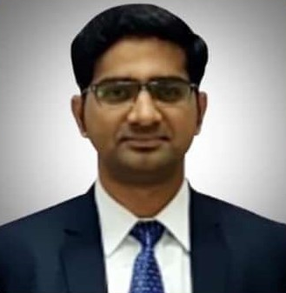
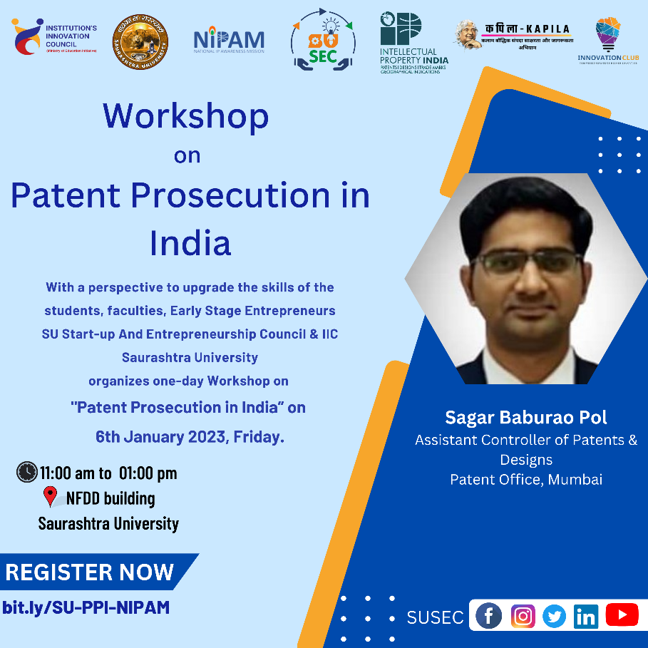

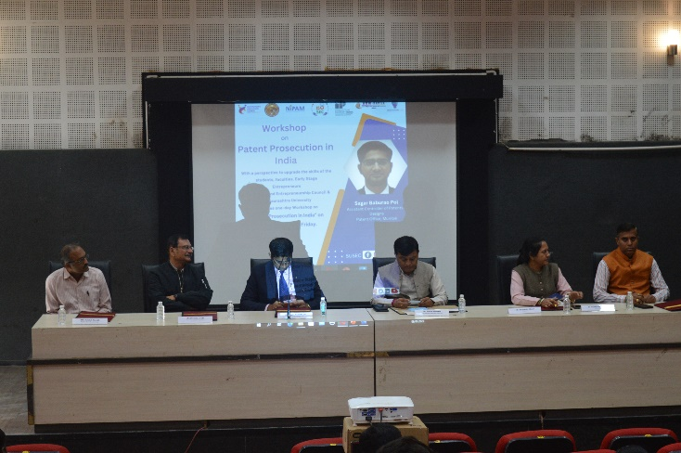
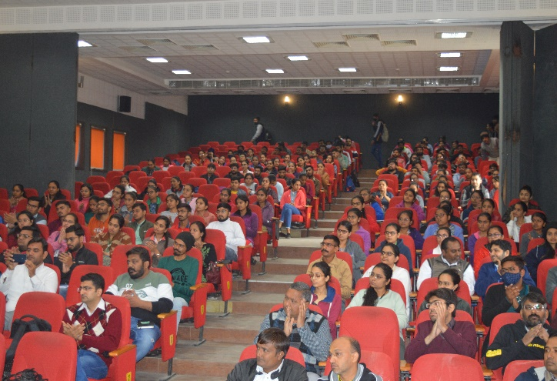

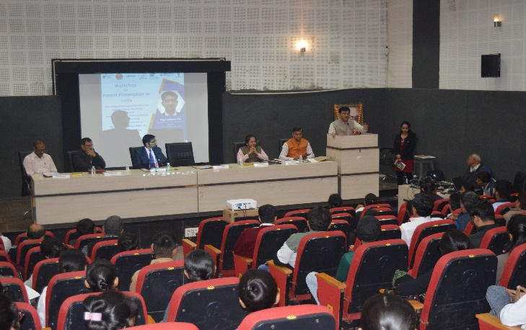
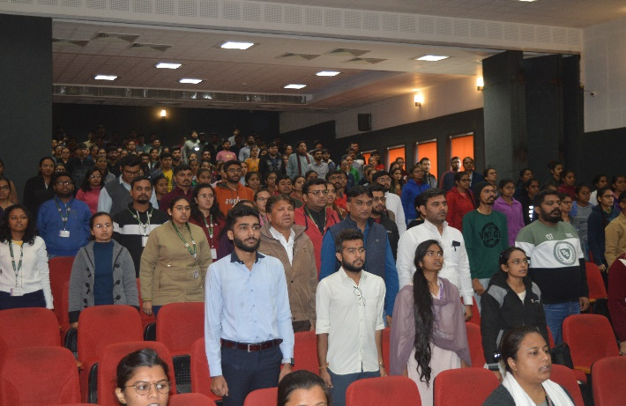

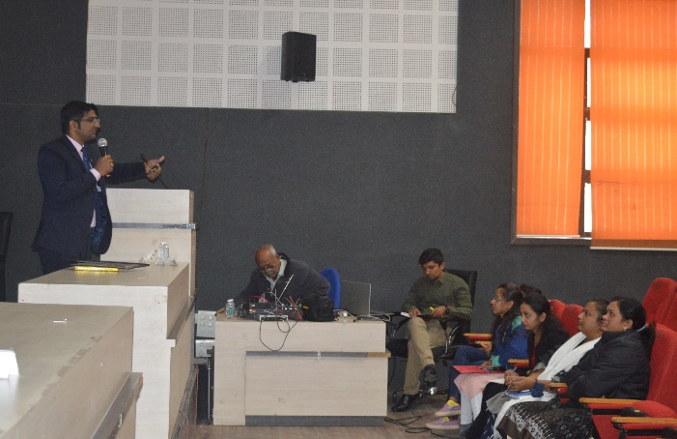
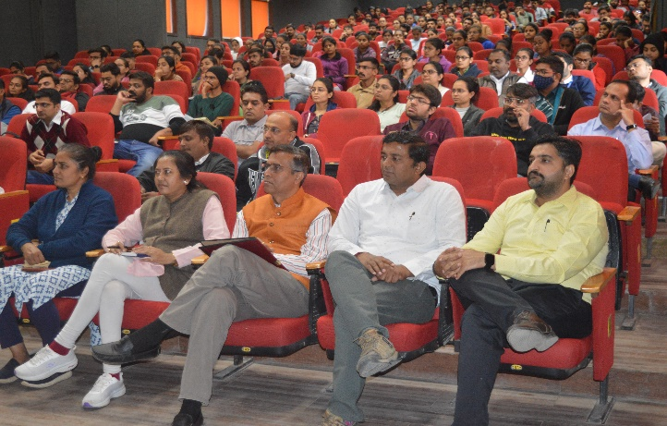
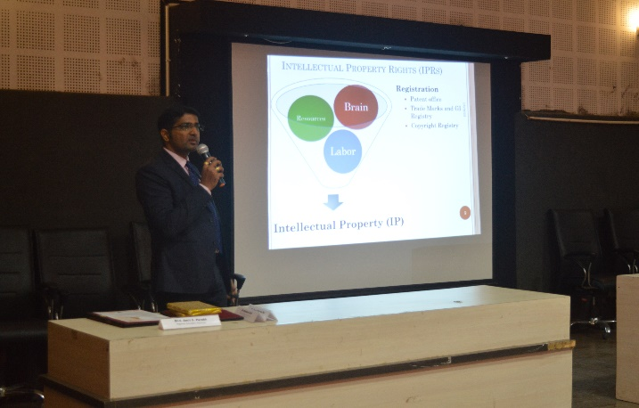
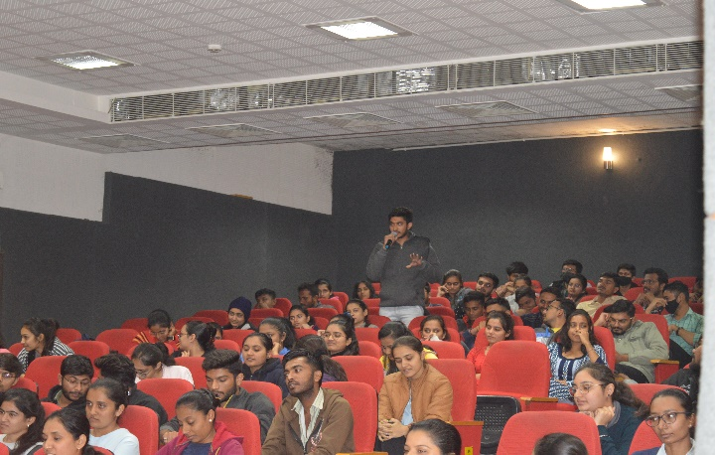

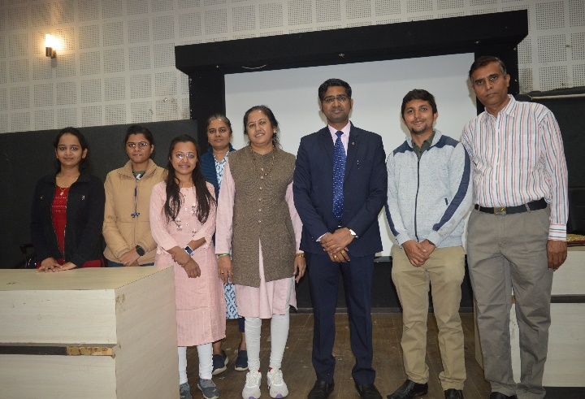
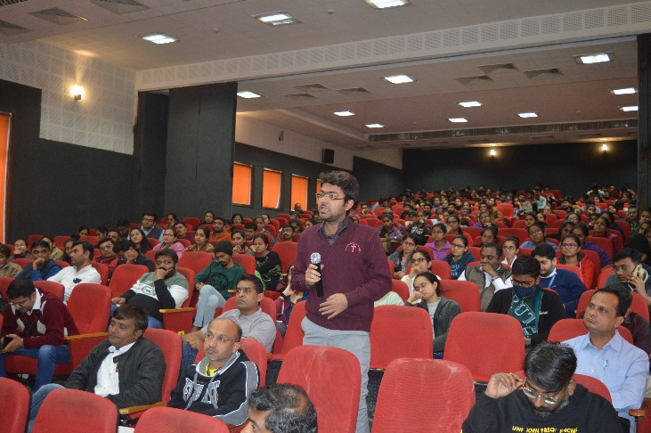

Connect Us:

https://www.linkedin.com/company/susec iic@sauuni.ac.in
https://www.facebook.com/iicsauuni bit.ly/SU-SSIP Location
https://www.instagram.com/susecrajkot

